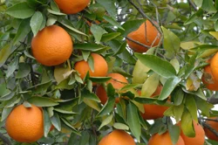
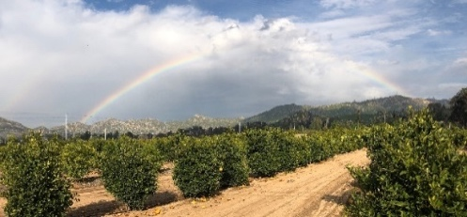
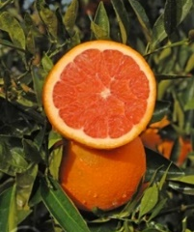

UC Riverside Citrus Field Day for growers and industry members
Thursday, March 7, 2024
Outdoor field meeting
7:15 a.m. to 2:00 p.m. (lunch included)
1060 Martin Luther King Blvd., Riverside, CA

7:15 Registration and Parking
7:45 Welcome, Tracy Kahn and Peggy Mauk, Dept Botany and Plant Sciences, UC Riverside
8:00 Updates on changes in pesticide regulations, update on Oriental Fruit fly quarantine, ACP/HLB Regulations – Delia Cioc, Ag Commissioner and Erik Downs, Deputy Ag Commissioner, Riverside County
Current invasive fruit fly quarantines in California – Nawal Sharma (CDFA) and Francisco Quintana (USDA)
Understanding Oriental Fruit Fly biology, Asian Citrus Psyllid control programs – Dr. Bodil Cass, UC Riverside
Phytosanitary treatment development for invasive species – Dr. Spencer Walse, USDA
Updates on Citrus Yellow Vein Clearing Virus in California and its proposed quarantine regulations – Anmol Joshi, Citrus Pest and Disease Prevention Division CDFA
Citrus Yellow Vein Associated Virus VS Citrus Yellow Vein Clearing Virus: FRIEND VS FOE – Dr. Georgios Vidalakis, UC Riverside
BREAK
Controlling Asian Citrus Psyllids using systemic insecticides – Dr. Frank Byrne, UC Riverside
Anthracnose of citrus Understanding the pathogen and its control – Dr. Peggy Mauk, UC Riverside
Spatial culturomics of the citrus microbiome to derive bioinoculants from functional microbiome studies – Dr. Caroline Roper & Christopher Drozd
Demonstration of autonomous systems for agriculture – Dr. Konstantinos Karydis, UC Riverside
Long-term solutions for citrus huanglongbing – Dr. Chandrika Ramadugu, UC Riverside
UCR Citrus Breeding and Evaluation Program Fruit Display – Toni Siebert Wooldridge, UC Riverside
Vendor demonstrations of autonomous systems
LUNCH

Continuing education PENDING

Link to program: https://capca.com/calendar/capca-socal-ucr-2024-citrus-day/

Direct link to registration: https://events.capca.com/event/21/register

UCR researchers appreciate the ongoing support of the Citrus Research Board

